Ministry of Education and Science of Ukraine
National Technical University of Ukraine
"Kyiv Polytechnic Institute named after Igor Sikorsky"
Educational and Scientific Institute of Atomic and Thermal Energy
Department of Digital Technologies in Energy

Graphics work
Topic: «Operations on texture coordinates.»
from the discipline: «Visualization of graphical and geometric information»

Variant 21

Performed by:
student of the TP-52mp group
Yarosh V.O.

Kyiv – 2025
1.Task

- Reuse texture mapping from Control task.
- Implement texture scaling (texture coordinates) scaling / rotation around user specified point- odd variants implement scaling, even variants implement rotation
- It has to be possible to move the point along the surface (u,v) space using a keyboard. E.g. keys A and D move the point along u parameter and keys W and S move the point along v parameter.

2. Theoretical information
2.1 Texture Coordinates in Rendering

Texture mapping assigns each vertex a 2D coordinate (u,v) used to sample a texture image. In the fragment shader, the color is obtained by sampling a texture sampler:
C = Texture(u, v),
Where:
UV coordinates are typically normalized to the range [0,1].

2.2 Scaling Around an Arbitrary Pivot in UV Space

To scale texture coordinates around a pivot point p = (u0, v0) by a factor k, we translate the coordinate system so that the pivot becomes the origin, apply scaling, then translate back:
uv' = p + (uv − p) * k,
Where:
uv is the original texture coordinate;
p is the pivot (center of scaling);
k is the scaling factor;
k > 1 increases repetition frequency (texture details appear smaller);
k < 1 decreases repetition frequency (texture details appear larger).

2.3 Handling Coordinates Outside [0,1]

After scaling, uv' can go outside [0,1]. There are two typical strategies:
1) Clamp: values outside [0,1] are clamped to the border, which may cause large areas to show border pixels.
2) Repeat: coordinates wrap around so the texture repeats.
In this work, wrapping is done via:
uvWrapped = fract(uv'),
Where:
This keeps coordinates inside [0,1) and produces repeating texture behavior.

2.4 Texture Sampling and Filtering

When a fragment shader evaluates texture2D(Sampler, uv), the GPU must convert continuous texture coordinates (u, v) into discrete texel (texture pixel) values. Because (u, v) is usually not aligned exactly with texel centers, the final sampled color depends on the texture filtering mode.

Two common filtering methods are:
– Nearest filtering: the color of the closest texel is used. This is fast and preserves sharp edges, but may produce visible pixelation.
– Linear filtering: the GPU linearly interpolates between neighboring texels. This produces smoother results, but can blur high-frequency details.

In addition, the behavior differs for:
– Magnification (texture appears larger on screen): controlled by TEXTURE_MAG_FILTER.
– Minification (texture appears smaller on screen): controlled by TEXTURE_MIN_FILTER.

Texture coordinate scaling directly affects sampling frequency. If the scaling factor k is large, the texture repeats more often across the surface, increasing minification and potentially causing aliasing (shimmering or moiré patterns). A standard technique to reduce aliasing is mipmapping, where the GPU samples from precomputed lower-resolution versions of the texture when the texture is heavily minified. This improves visual stability and reduces artifacts when the texture is scaled or viewed at a distance.

3. Implementation Details
3.1 Project Structure and Entry Point

The application is a WebGL-based renderer that draws a textured parametric surface in real time.
– In index.html: Defines the canvas and UI sliders. Loads scripts in order: math utilities, shaders, model generation, texture loader, and main application logic.
– In main.js: Initializes WebGL, compiles shaders, sets up uniforms/attributes, handles input, and renders each frame.
– In model.js: Generates the parametric surface mesh (positions, normals, tangents, UVs) and uploads them to GPU buffers.
– In TextureHandler.js: Loads image textures asynchronously and binds them to WebGL textures.
– In shader.gpu: Contains GLSL vertex and fragment shader sources.

3.2 Reusing Texture Mapping

The project reuses the UV mapping from the previous (control) task. The Klein bottle surface is generated as a regular parametric grid with nu segments in the u direction and nv segments in the v direction (SurfaceGrid in model.js). For each vertex (iu, iv) the texture coordinates are computed procedurally as normalized parameters:
s = iu / nu, t = iv / nv.

3.3 Shader Implementation (UV Scaling)

Texture scaling is implemented on the GPU side to avoid rebuilding buffers each time the user changes parameters. Two uniforms were introduced:
– uniform vec2 TexPivot; – pivot point (u0, v0) in texture space;
– uniform float TexScale; – scale coefficient k.
The pivot-based scaling is computed directly in the vertex shader using the standard affine transformation:
uv' = TexPivot + (uv − TexPivot) * TexScale.

3.4 Keyboard Interaction

The pivot point is moved in texture space using a keyboard handler. The application listens for keydown events and changes (u0, v0) in small steps:
- A: u -= step;
- D: u += step;
- W: v += step;
- S: v -= step.
To prevent invalid values, the pivot is clamped into the range [0,1]. This avoids situations where the pivot drifts infinitely and makes interaction predictable. After updating the pivot, the renderer is refreshed so that the effect is visible immediately.

3.3 CPU-side Control
On the CPU side, current transformation parameters are stored as global state variables: texPivotU, texPivotV – pivot coordinates; texScale – scaling factor.
After shader compilation, uniform locations are queried once in initGL() using gl.getUniformLocation. During each render (draw()), the current values are uploaded to the GPU:
gl.uniform2fv(shProgram.iTexPivot, [texPivotU, texPivotV]);
gl.uniform1f(shProgram.iTexScale, texScale);
Because only uniforms are updated, the transformation is lightweight and reacts instantly to user input. The vertex buffers (positions, normals, UVs) remain unchanged, which keeps the implementation efficient and easy to maintain.

4. User's instruction
4.1 Interface Overview
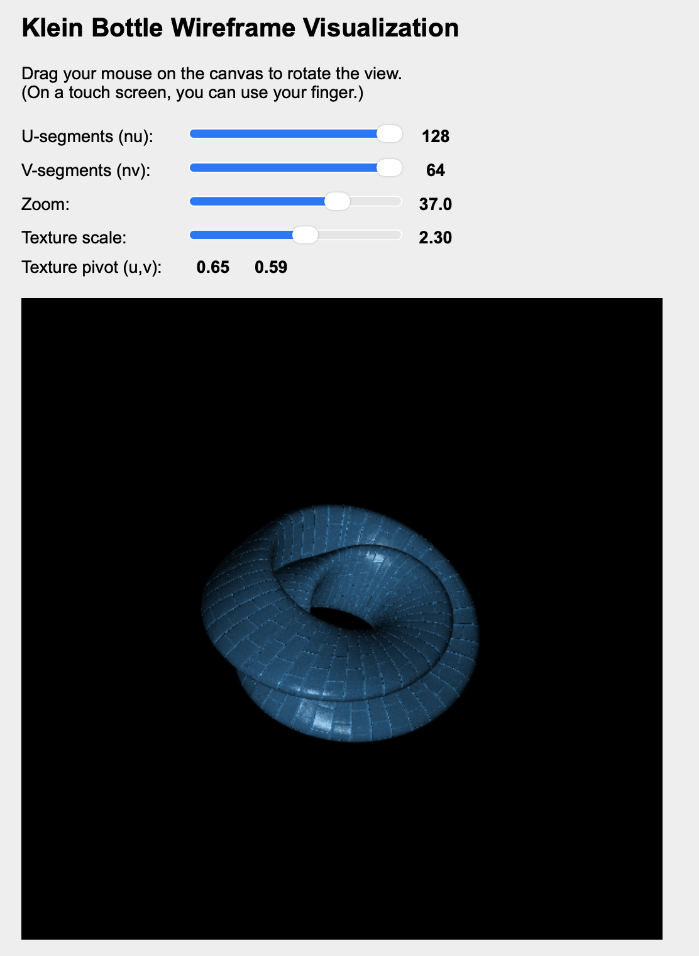
Figure 4.1 – User interface
4.2 Camera Control

- Drag mouse on canvas to rotate (trackball).
- Use the Zoom slider to change distance.

4.3 Texture Scaling

Use Texture scale slider:
- 1.00: default mapping
- 2.00–4.00: stronger scaling (more repetitions)

4.4 Moving the Pivot

- A / D: move pivot along u
- W / S: move pivot along v

4.5 Screenshot

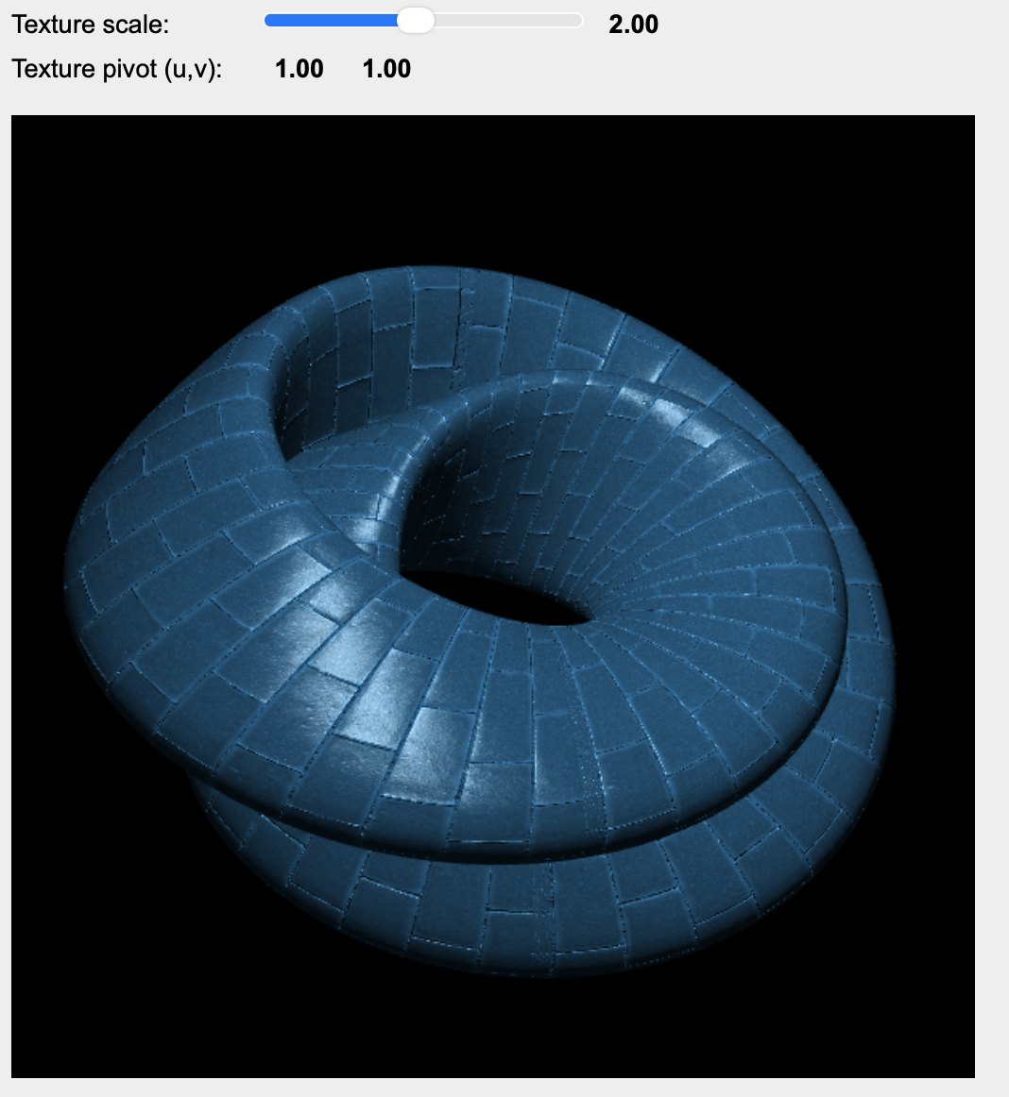
Figure 4.2 – scale = 2.0, pivot = (1.0,1.0)
5. Source code
model.js
'use strict';

function klein(u, v, a = 2) {
const cos_u2 = Math.cos(u / 2);
const sin_u2 = Math.sin(u / 2);
const cos_u = Math.cos(u);
const sin_u = Math.sin(u);
const sin_v = Math.sin(v);
const sin_2v = Math.sin(2 * v);

const r = a + cos_u2 * sin_v - sin_u2 * sin_2v;

const x = r * cos_u;
const y = r * sin_u;
const z = sin_u2 * sin_v + cos_u2 * sin_2v;

return [x, y, z];
}

function SurfaceGrid(nu, nv) {
this.nu = nu || 64;
this.nv = nv || 32;

this.positionBuffer = null;
this.normalBuffer = null;
this.texCoordBuffer = null;
this.tangentBuffer = null;
this.indexBuffer = null;
this.indexCount = 0;

function vec3Sub(a, b) {
return [a[0] - b[0], a[1] - b[1], a[2] - b[2]];
}

function vec3Cross(a, b) {
return [
a[1] * b[2] - a[2] * b[1],
a[2] * b[0] - a[0] * b[2],
a[0] * b[1] - a[1] * b[0]
];
}

function vec3Dot(a, b) {
return a[0] * b[0] + a[1] * b[1] + a[2] * b[2];
}

function vec3Length(a) {
return Math.sqrt(a[0] * a[0] + a[1] * a[1] + a[2] * a[2]);
}

function vec3Normalize(a) {
const len = vec3Length(a);
if (len > 1e-8) {
return [a[0] / len, a[1] / len, a[2] / len];
}
return [0, 0, 0];
}

function clamp(x, min, max) {
return Math.max(min, Math.min(max, x));
}

function angleBetween(u, v) {
const un = vec3Normalize(u);
const vn = vec3Normalize(v);
const d = clamp(vec3Dot(un, vn), -1, 1);
return Math.acos(d);
}

this.generate = function() {
const twoPi = 2 * Math.PI;

const positions = [];
const normalsAccum = [];
const texCoords = [];
const tangents = [];

const vertCountU = this.nu + 1;
const vertCountV = this.nv + 1;
const vertCount = vertCountU * vertCountV;

for (let i = 0; i < vertCount; i++) {
normalsAccum.push([0, 0, 0]);
}

for (let iv = 0; iv <= this.nv; iv++) {
const v = (iv / this.nv) * twoPi;
for (let iu = 0; iu <= this.nu; iu++) {
const u = (iu / this.nu) * twoPi;
const p = klein(u, v);
positions.push(p[0], p[1], p[2]);

const s = iu / this.nu;
const t = iv / this.nv;
texCoords.push(s, t);

const du = twoPi / this.nu;
const dv = twoPi / this.nv;
const pu = klein(u + du, v);
const pv = klein(u, v + dv);
const dPdu = vec3Sub(pu, p);
const dPdv = vec3Sub(pv, p);

const nParam = vec3Normalize(vec3Cross(dPdu, dPdv));
let tParam = vec3Normalize(dPdu);
const sign = (vec3Dot(vec3Cross(nParam, tParam), vec3Normalize(dPdv)) < 0.0) ? -1.0 : 1.0;
tangents.push(tParam[0], tParam[1], tParam[2], sign);
}
}

const indices = [];
for (let iv = 0; iv < this.nv; iv++) {
for (let iu = 0; iu < this.nu; iu++) {
const a = iv * vertCountU + iu;
const b = a + 1;
const c = (iv + 1) * vertCountU + iu;
const d = c + 1;
indices.push(a, c, b);
indices.push(b, c, d);
}
}

for (let i = 0; i < indices.length; i += 3) {
const ia = indices[i + 0];
const ib = indices[i + 1];
const ic = indices[i + 2];

const pa = [positions[ia * 3 + 0], positions[ia * 3 + 1], positions[ia * 3 + 2]];
const pb = [positions[ib * 3 + 0], positions[ib * 3 + 1], positions[ib * 3 + 2]];
const pc = [positions[ic * 3 + 0], positions[ic * 3 + 1], positions[ic * 3 + 2]];

const e1 = vec3Sub(pb, pa);
const e2 = vec3Sub(pc, pa);
const faceN = vec3Normalize(vec3Cross(e1, e2));

const angleA = angleBetween(vec3Sub(pb, pa), vec3Sub(pc, pa));
const angleB = angleBetween(vec3Sub(pa, pb), vec3Sub(pc, pb));
const angleC = angleBetween(vec3Sub(pa, pc), vec3Sub(pb, pc));

normalsAccum[ia][0] += faceN[0] * angleA;
normalsAccum[ia][1] += faceN[1] * angleA;
normalsAccum[ia][2] += faceN[2] * angleA;

normalsAccum[ib][0] += faceN[0] * angleB;
normalsAccum[ib][1] += faceN[1] * angleB;
normalsAccum[ib][2] += faceN[2] * angleB;

normalsAccum[ic][0] += faceN[0] * angleC;
normalsAccum[ic][1] += faceN[1] * angleC;
normalsAccum[ic][2] += faceN[2] * angleC;
}

const normals = [];
for (let i = 0; i < normalsAccum.length; i++) {
const n = vec3Normalize(normalsAccum[i]);
normals.push(n[0], n[1], n[2]);
}

if (this.positionBuffer) {
gl.deleteBuffer(this.positionBuffer);
}
if (this.normalBuffer) {
gl.deleteBuffer(this.normalBuffer);
}
if (this.texCoordBuffer) {
gl.deleteBuffer(this.texCoordBuffer);
}
if (this.tangentBuffer) {
gl.deleteBuffer(this.tangentBuffer);
}
if (this.indexBuffer) {
gl.deleteBuffer(this.indexBuffer);
}

this.positionBuffer = gl.createBuffer();
gl.bindBuffer(gl.ARRAY_BUFFER, this.positionBuffer);
gl.bufferData(gl.ARRAY_BUFFER, new Float32Array(positions), gl.STATIC_DRAW);

this.normalBuffer = gl.createBuffer();
gl.bindBuffer(gl.ARRAY_BUFFER, this.normalBuffer);
gl.bufferData(gl.ARRAY_BUFFER, new Float32Array(normals), gl.STATIC_DRAW);

this.texCoordBuffer = gl.createBuffer();
gl.bindBuffer(gl.ARRAY_BUFFER, this.texCoordBuffer);
gl.bufferData(gl.ARRAY_BUFFER, new Float32Array(texCoords), gl.STATIC_DRAW);

this.tangentBuffer = gl.createBuffer();
gl.bindBuffer(gl.ARRAY_BUFFER, this.tangentBuffer);
gl.bufferData(gl.ARRAY_BUFFER, new Float32Array(tangents), gl.STATIC_DRAW);

this.indexBuffer = gl.createBuffer();
gl.bindBuffer(gl.ELEMENT_ARRAY_BUFFER, this.indexBuffer);
gl.bufferData(gl.ELEMENT_ARRAY_BUFFER, new Uint16Array(indices), gl.STATIC_DRAW);
this.indexCount = indices.length;
};

this.drawTriangles = function() {
if (!this.positionBuffer || !this.normalBuffer || !this.texCoordBuffer || !this.tangentBuffer || !this.indexBuffer || this.indexCount === 0) {
return;
}

gl.bindBuffer(gl.ARRAY_BUFFER, this.positionBuffer);
gl.vertexAttribPointer(shProgram.iAttribVertex, 3, gl.FLOAT, false, 0, 0);
gl.enableVertexAttribArray(shProgram.iAttribVertex);

gl.bindBuffer(gl.ARRAY_BUFFER, this.normalBuffer);
gl.vertexAttribPointer(shProgram.iAttribNormal, 3, gl.FLOAT, false, 0, 0);
gl.enableVertexAttribArray(shProgram.iAttribNormal);

gl.bindBuffer(gl.ARRAY_BUFFER, this.texCoordBuffer);
gl.vertexAttribPointer(shProgram.iAttribTexCoord, 2, gl.FLOAT, false, 0, 0);
gl.enableVertexAttribArray(shProgram.iAttribTexCoord);

gl.bindBuffer(gl.ARRAY_BUFFER, this.tangentBuffer);
gl.vertexAttribPointer(shProgram.iAttribTangent, 4, gl.FLOAT, false, 0, 0);
gl.enableVertexAttribArray(shProgram.iAttribTangent);

gl.bindBuffer(gl.ELEMENT_ARRAY_BUFFER, this.indexBuffer);
gl.drawElements(gl.TRIANGLES, this.indexCount, gl.UNSIGNED_SHORT, 0);
};

this.updateGrid = function(nu, nv) {
this.nu = nu;
this.nv = nv;
this.generate();
};

this.generate();
}

main.js:
'use strict';

let gl;
let surface;
let shProgram;
let spaceball;
let zoomDistance = 10;
let animationRequestId = null;

let texPivotU = 0.5;
let texPivotV = 0.5;
let texScale = 1.0;

// Constructor
function ShaderProgram(name, program) {

this.name = name;
this.prog = program;

// Location of the attribute variable in the shader program.
this.iAttribVertex = -1;
this.iAttribNormal = -1;
this.iAttribTexCoord = -1;
this.iAttribTangent = -1;
// Location of the uniform specifying a color for the primitive.
this.iColor = -1;
// Location of the uniform matrix representing the combined transformation.
this.iModelViewProjectionMatrix = -1;

this.iModelViewMatrix = -1;
this.iNormalMatrix = -1;
this.iLightPosition = -1;

this.iDiffuseMap = -1;
this.iSpecularMap = -1;
this.iNormalMap = -1;

this.iTexPivot = -1;
this.iTexScale = -1;

this.Use = function() {
gl.useProgram(this.prog);
}
}

let diffuseTexture = null;
let specularTexture = null;
let normalTexture = null;

function draw(timeMs) {
gl.clearColor(0,0,0,1);
gl.clear(gl.COLOR_BUFFER_BIT | gl.DEPTH_BUFFER_BIT);

let projection = m4.perspective(Math.PI/8, 1, 0.1, 100);

/* Get the view matrix from the SimpleRotator object.*/
let modelView = spaceball.getViewMatrix();

let rotateToPointZero = m4.axisRotation([0.707,0.707,0], 0.7);
let translateToPointZero = m4.translation(0,0,-zoomDistance);

let matAccum0 = m4.multiply(rotateToPointZero, modelView );
let matAccum1 = m4.multiply(translateToPointZero, matAccum0 );

/* Multiply the projection matrix times the modelview matrix to give the
combined transformation matrix, and send that to the shader program. */
let modelViewProjection = m4.multiply(projection, matAccum1 );

gl.uniformMatrix4fv(shProgram.iModelViewProjectionMatrix, false, modelViewProjection );
gl.uniformMatrix4fv(shProgram.iModelViewMatrix, false, matAccum1 );

const mvInv = m4.inverse(matAccum1);
const mvInvT = m4.transpose(mvInv);
const normalMatrix = new Float32Array([
mvInvT[0], mvInvT[1], mvInvT[2],
mvInvT[4], mvInvT[5], mvInvT[6],
mvInvT[8], mvInvT[9], mvInvT[10],
]);
gl.uniformMatrix3fv(shProgram.iNormalMatrix, false, normalMatrix);

const t = (timeMs !== undefined ? timeMs : performance.now()) * 0.001;
const lightRadius = 8.0;
const lightHeight = 2.5;
const lightWorld = [lightRadius * Math.cos(t), lightHeight, lightRadius * Math.sin(t)];
const lightView = m4.transformPoint(matAccum1, lightWorld);
gl.uniform3fv(shProgram.iLightPosition, lightView);

gl.activeTexture(gl.TEXTURE0);
gl.bindTexture(gl.TEXTURE_2D, diffuseTexture);
gl.uniform1i(shProgram.iDiffuseMap, 0);

gl.activeTexture(gl.TEXTURE1);
gl.bindTexture(gl.TEXTURE_2D, specularTexture);
gl.uniform1i(shProgram.iSpecularMap, 1);

gl.activeTexture(gl.TEXTURE2);
gl.bindTexture(gl.TEXTURE_2D, normalTexture);
gl.uniform1i(shProgram.iNormalMap, 2);

gl.uniform2fv(shProgram.iTexPivot, [texPivotU, texPivotV]);
gl.uniform1f(shProgram.iTexScale, texScale);

gl.uniform4fv(shProgram.iColor, [0.2, 0.7, 1.0, 1.0]);
surface.drawTriangles();
}

/* Initialize the WebGL context. Called from init() */
function initGL() {
let prog = createProgram( gl, vertexShaderSource, fragmentShaderSource );

shProgram = new ShaderProgram('Basic', prog);
shProgram.Use();

shProgram.iAttribVertex = gl.getAttribLocation(prog, "vertex");
shProgram.iAttribNormal = gl.getAttribLocation(prog, "normal");
shProgram.iAttribTexCoord = gl.getAttribLocation(prog, "texCoord");
shProgram.iAttribTangent = gl.getAttribLocation(prog, "tangent");
shProgram.iModelViewProjectionMatrix = gl.getUniformLocation(prog, "ModelViewProjectionMatrix");
shProgram.iModelViewMatrix = gl.getUniformLocation(prog, "ModelViewMatrix");
shProgram.iNormalMatrix = gl.getUniformLocation(prog, "NormalMatrix");
shProgram.iLightPosition = gl.getUniformLocation(prog, "LightPosition");
shProgram.iColor = gl.getUniformLocation(prog, "color");

shProgram.iDiffuseMap = gl.getUniformLocation(prog, "DiffuseMap");
shProgram.iSpecularMap = gl.getUniformLocation(prog, "SpecularMap");
shProgram.iNormalMap = gl.getUniformLocation(prog, "NormalMap");

shProgram.iTexPivot = gl.getUniformLocation(prog, "TexPivot");
shProgram.iTexScale = gl.getUniformLocation(prog, "TexScale");

diffuseTexture = LoadTexture('./diffuse.jpg', new Uint8Array([255, 255, 255, 255]));
specularTexture = LoadTexture('./specular.jpg', new Uint8Array([255, 255, 255, 255]));
normalTexture = LoadTexture('./normal.jpg', new Uint8Array([128, 128, 255, 255]));

surface = new SurfaceGrid(64, 32);

gl.enable(gl.DEPTH_TEST);
}

/* Creates a program for use in the WebGL context gl, and returns the
* identifier for that program. If an error occurs while compiling or
* linking the program, an exception of type Error is thrown. The error
* string contains the compilation or linking error. If no error occurs,
* the program identifier is the return value of the function.
* The second and third parameters are strings that contain the
* source code for the vertex shader and for the fragment shader.
*/
function createProgram(gl, vShader, fShader) {
let vsh = gl.createShader( gl.VERTEX_SHADER );
gl.shaderSource(vsh,vShader);
gl.compileShader(vsh);
if ( ! gl.getShaderParameter(vsh, gl.COMPILE_STATUS) ) {
throw new Error("Error in vertex shader: " + gl.getShaderInfoLog(vsh));
}
let fsh = gl.createShader( gl.FRAGMENT_SHADER );
gl.shaderSource(fsh, fShader);
gl.compileShader(fsh);
if ( ! gl.getShaderParameter(fsh, gl.COMPILE_STATUS) ) {
throw new Error("Error in fragment shader: " + gl.getShaderInfoLog(fsh));
}
let prog = gl.createProgram();
gl.attachShader(prog,vsh);
gl.attachShader(prog, fsh);
gl.linkProgram(prog);
if ( ! gl.getProgramParameter( prog, gl.LINK_STATUS) ) {
throw new Error("Link error in program: " + gl.getProgramInfoLog(prog));
}
return prog;
}

/**
* initialization function that will be called when the page has loaded
*/
function init() {
let canvas;
try {
canvas = document.getElementById("webglcanvas");
gl = canvas.getContext("webgl");
if ( ! gl ) {
throw "Browser does not support WebGL";
}
}
catch (e) {
document.getElementById("canvas-holder").innerHTML =
"<p>Sorry, could not get a WebGL graphics context.</p>";
return;
}
try {
initGL(); // initialize the WebGL graphics context
}
catch (e) {
document.getElementById("canvas-holder").innerHTML =
"<p>Sorry, could not initialize the WebGL graphics context: " + e + "</p>";
return;
}

spaceball = new TrackballRotator(canvas, draw, 0);

const nuSlider = document.getElementById('nuSlider');
const nvSlider = document.getElementById('nvSlider');
const zoomSlider = document.getElementById('zoomSlider');
const nuValue = document.getElementById('nuValue');
const nvValue = document.getElementById('nvValue');
const zoomValue = document.getElementById('zoomValue');

const texScaleSlider = document.getElementById('texScaleSlider');
const texScaleValue = document.getElementById('texScaleValue');
const texPivotUValue = document.getElementById('texPivotUValue');
const texPivotVValue = document.getElementById('texPivotVValue');

if (nuSlider && nvSlider) {
nuSlider.addEventListener('input', function() {
const nu = parseInt(nuSlider.value);
const nv = parseInt(nvSlider.value);
nuValue.textContent = nu;
surface.updateGrid(nu, nv);
draw();
});

nvSlider.addEventListener('input', function() {
const nu = parseInt(nuSlider.value);
const nv = parseInt(nvSlider.value);
nvValue.textContent = nv;
surface.updateGrid(nu, nv);
draw();
});
}

if (zoomSlider) {
zoomSlider.addEventListener('input', function() {
zoomDistance = parseFloat(zoomSlider.value);
zoomValue.textContent = zoomDistance.toFixed(1);
draw();
});
}

if (texScaleSlider) {
texScaleSlider.addEventListener('input', function() {
texScale = parseFloat(texScaleSlider.value);
if (texScaleValue) {
texScaleValue.textContent = texScale.toFixed(2);
}
draw();
});
}

const updatePivotLabels = function() {
if (texPivotUValue) {
texPivotUValue.textContent = texPivotU.toFixed(2);
}
if (texPivotVValue) {
texPivotVValue.textContent = texPivotV.toFixed(2);
}
};
updatePivotLabels();

window.addEventListener('keydown', function(e) {
const key = (e.key || '').toLowerCase();
const step = 0.01;
let changed = false;

if (key === 'a') {
texPivotU = Math.max(0.0, Math.min(1.0, texPivotU - step));
changed = true;
} else if (key === 'd') {
texPivotU = Math.max(0.0, Math.min(1.0, texPivotU + step));
changed = true;
} else if (key === 'w') {
texPivotV = Math.max(0.0, Math.min(1.0, texPivotV + step));
changed = true;
} else if (key === 's') {
texPivotV = Math.max(0.0, Math.min(1.0, texPivotV - step));
changed = true;
}

if (changed) {
updatePivotLabels();
draw();
}
});

if (animationRequestId !== null) {
cancelAnimationFrame(animationRequestId);
}
const animate = function(timeMs) {
draw(timeMs);
animationRequestId = requestAnimationFrame(animate);
};
animationRequestId = requestAnimationFrame(animate);
}

